**1.Grafana Introduction**

**Purpose:**

* Grafana is an open-source platform for data visualization, monitoring and analysis.
* Grafana allows users to create dashboards with panels, each representing specific metrics over a set **time-frame.**

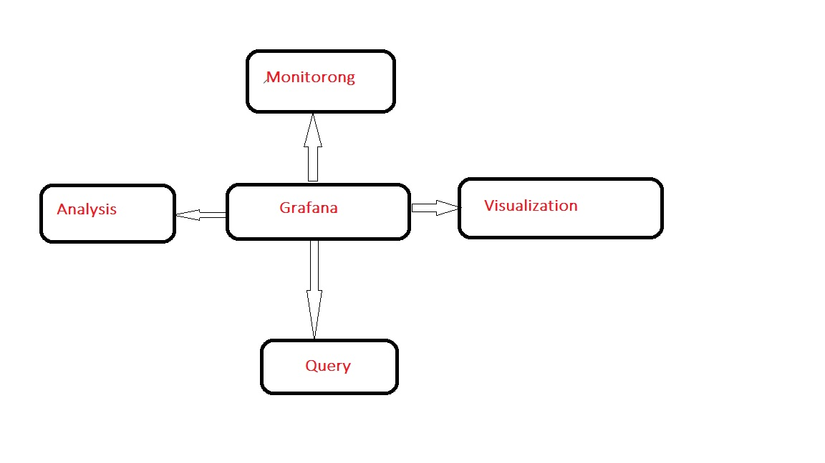

* Grafana is designed to work as a UI for analyzing and visualizing metrics such as **system CPU, Memory, disk** and **I/O** utilization.

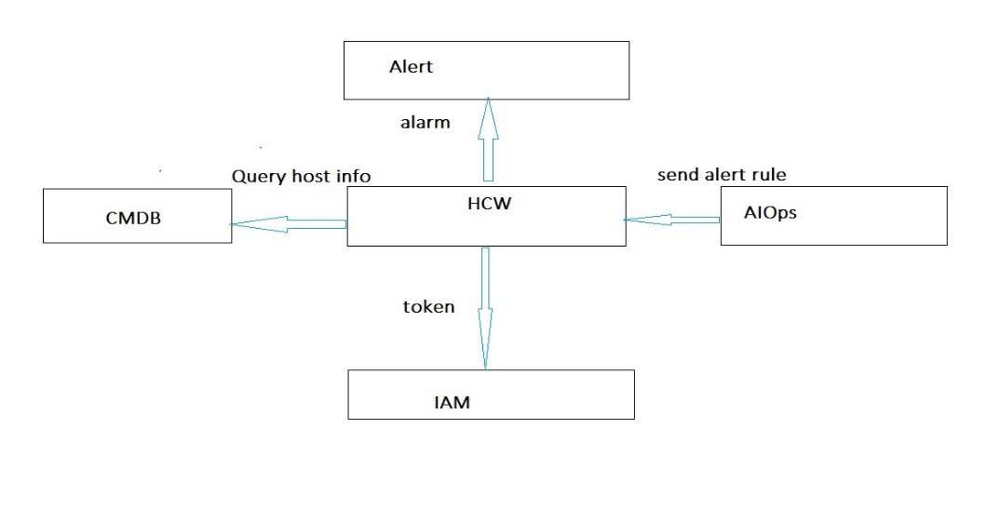

* For each data source, Grafana has a different Query Editor customized for the features and capabilities that are included in that source.

**2.Query Editor:**

**Query Editor** for **querying.** Each data source has a different query editor customize for the specific data source, meaning that the syntax used varies according to the source.

Visualization in Grafana are called **pannels**, and users can create dashboard containing panels for different data sources. Grafana supports

* Graph
* Singletest
* Table

Syntax:

We have syntax/formula for add the Query,

**Plugin name+_+metrics name+{filter words}**

For example:

**“CPU”** is the plugin name

**“idle”** is the plugin name

**“ip=xxx”** is the plugin name

**cpu_util{scope_name~”.*oplatform.*”}**

**“CPU”** is the plugin name

**“util”** is the plugin name

**“scope name=~”.\***oplatform.*”is the filter words

Grafana users can make use of large environment of ready-made dashboards for different data types and sources

Grafana is visualized GUI measurement tool. This document describe how to use the graph, singletest, and panels.

3.Prometheus

Introduction:

Prometheus provides a functional query language called PromQL (Prometheus Query Language)

that lets the user select and aggregate time series data in real time. The result of an expression can either be shown as a graph, viewed as tabular datas

For mor

4.Common Charts

After creating a dashboard, you can create charts as required.

4.1 Graph Settings

**1. Adding a Graph**

You can add a graph when running the ADD ROW or ADD PANEL command.

(Choose Graph)

**2.Configuring the Graph (General)**

Click Panel Title, select edit, and click General (The metrics tab page is displayed by default)

To modify the title.

**3.Configuring graph Metrics**

Click Panel title. On the Edit page that is displayed, select Data Source:

Prometheus_mater, and click Add Query. Set search criteria. For example, if the IP address is cpu_idle(ip=~”10.62.88.13”), the CPU idle indicator of the host with the IP address 10.62.88.13 is required.

**4.Configuring the graph-prometheus Formula**

Click the panel title, select HCW_prometheus from the Data Source drop down list box, and click Add Query. Enter the domain, indicator, host, time, add formula, and click quey. The system automatically generates the query criteria that meet the formula.

Ex: min(cpu_idle{scope_name=”cloudeye”, ip=~”10.62.88.13”}).

The following formalas are supported:

max(): Maximum value of the returned data

min(): minimum value of the returned data.

avg(): Average value of the returned data

abs(): Absloute value of the returned data

absent(): If the parameter has no element, an empty vector is returned. If the parameter has elements, the return value is the 1 element vector of 1.

abs(v instant-vector)

**5.Configuring graph-Axes**

On this tab page, you can configure the horizontal and vertical axes of the graph. For example, you can configure whether to display the show parameter and set unit to the data type for statistics.

**6.Configuring the graph-Legend (description)**

**7.Configuring graph – Display**

**Singlestat Settings**

1.Adding singlestat

When running the ADD ROW or ADD panel command, you can add a singlestat task.

2. Configuring singlestat – General

Click panel title, select Edit, click general (the metrics tab page is displayed by default) to modify the title.

3. Configuring singlestat- Metrics

Click panel title. On the edit page that is displayed, select Prometheus_mater as the data source, and click Add Query. Set search criteria.

4. Configuring singlestat – value Mapping

**Table Settings**

1.Adding a table

You can choose to add a table when running the ADD ROW od ADD panel command.

2. Configuring a Table(General)

Click Panel Title, select Edit, and click General (the Metrics tab page is displayed by default) to modify the title.

3. Configuring tables – Metrics

Click panel title on the Edit page this is displayed, select Prometheus_mater as the data source, and click, and click Add Query, Set search criteria.

4. Configuring the table- Options

5. Configuring a table – Column Sryle

As shown in the following figure, click the column of the table to get to another dashboard.

Configure the Mteric column and click to go to dashboard where the URL is located.

**5. Dashboard basic general Settings**

**1. Creating a dashboard**

Click the Grafana icon, choose Dashboards from the navigation tree on the left, and click new to create a dashboard.

2**. Set Dashboard – General**

Click the configuration icon, choose settings , and Set Name in Details.

3**. Setting dashboard – Rows**

Set Row labels.

**4. Setting dashboard – Links**

Enter the link address and title

**5. Setting template variables**

Template variables can dynamically control the query statements in the panel and are displayed in the upper left corner the panel after being set.

Note: After template variables are set, the query formula of metrics in the chart can be replaced with variable names. Modify the variables to modify the query formula of the metrics. Configuration method.

Click the configuration icon, select Temp Variables, click new and ser variables.

6. Row General settings

1. Adding a Row

Click ADD ROW to add a row.

2. Configure a Row

Move the cursor to the three verticals on the displayed configuration menu, choose Row Options to modify the row tittle. The information such as the title of the line is displayed. You can Expand or Collapse the content in a line.

3. Add Panel

Move the cursor to the tree vertical points on the left. In the displayed configuration menu, choose Add panel to add a chart to the row.

**7. Summary**

Grafana is an open-source platform for data **visualization**, **monitoring** and **analysis.** Grafana allows users to create dashboards with panels, each representing specific metrics over a set **time-frame.** By using garfana we can able to create and configure dashboards for visualization. Based on **query,** we can change our metric and visualize our graph.

* First we need install Prometheus in our server.
* Later we need to install node-exporter in the server to be monitor.
* Then we are able see the data in Prometheus.
* Next we need to install Grafana in our server
* Configure the Prometheus in Grafana under the data source option.
* Node Exporter:-
* ---------------------
* Set up and configured Node Exporter to collect Linux system metrics like CPU load and disk I/O. Node Exporter will expose these as Prometheus-style metrics.
* Configured Prometheus to scrape Node Exporter metrics and optionally ship them to Grafana Cloud.

Visit Links:

[https://prometheus.io/docs/prometheus/latest/getting started/](https://prometheus.io/docs/prometheus/latest/getting%20started/)

<https://prometheus.io/docs/prometheus/latest/querying/functions/>

https://youtu.be/OuQ2bdpejjk